# Design of “Wildlife wonders”. Part 2.

*by Oleksandr Tunik*

General design of my website can be seen in the “Initial Design document”.

Updates:  
- Quiz webpage with heavy implementation of JavaScript, jQuery and advanced HTML.

After learning about wildlife of different continents visitors of the website can challenge their knowledge by completing a quiz of separating animals by continents. This functionality uses:

1. jQuery for drag and drop (snap) functions.
2. Advanced HTML for localStorage (storing high score in the quiz)



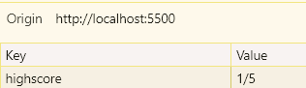

1. Javascript for random selection of animals and checking the answers

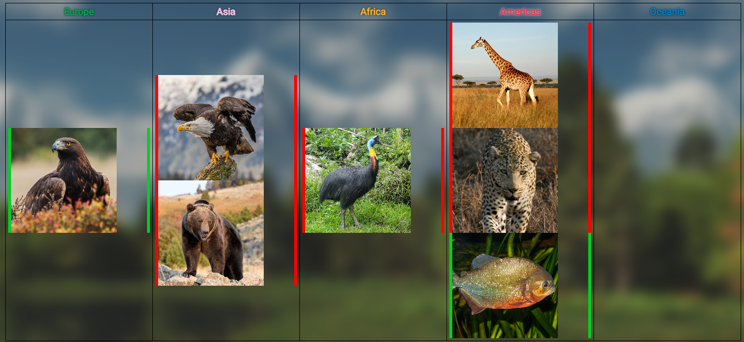

1. Javascript for validating a form with name and email of the user (also uses regular expressions).

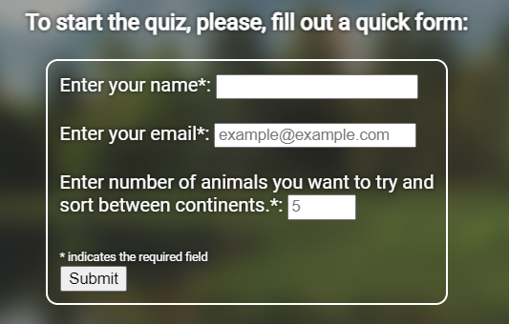

1. The “device not supported” text was added for the quiz page for mobile, as jQuery drag and drop feature’s do not work well with mobile, which also improves accessibility and saves from errors.



1. Black and purple have been chosen as an accent colors for the Quiz, as it is supposed to be something hidden, premium and just for professionals (at least invoke such feelings in users).

- Added usage of location data (advanced HTML) to all general pages about continents

Now the distance between current user’s location and approximate centre of the continent is calculated using a formula [1]. Latitude and longitude of both points give the distance in km as a result.

- Added 6 more pages for each animal in Asia with more details about them. These pages do utilize CSS bootstrap for easier and more intuitive styling.

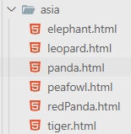

- For accessibility, every image has an alt, which also prevents any errors if the image source is not available anymore. The website have also been tested for different screen sizes, information is available below.

Testing:

Quiz mechanism was tested by hand multiple times in different scenarios, debugging has been done to alleviate any issues.

The distances, calculated by latitude and longitude have been checked and are in close range of error. [2]

To test my website for markup standards I used <https://validator.w3.org/>. I also tested adaptability of my website to a mobile device and different screen sizes in general, using built in Chrome developer features.

[1] <https://community.fabric.microsoft.com/t5/Desktop/How-to-calculate-lat-long-distance/td-p/1488227>

[2] <https://www.distancefromto.net/>